To:

Price Quotation #__________:
Tritone MoldJet Dominant / Dim Manufacturing Solution
(INFORMATION FOR RESELLER, NOT FOR PUBLICATION)
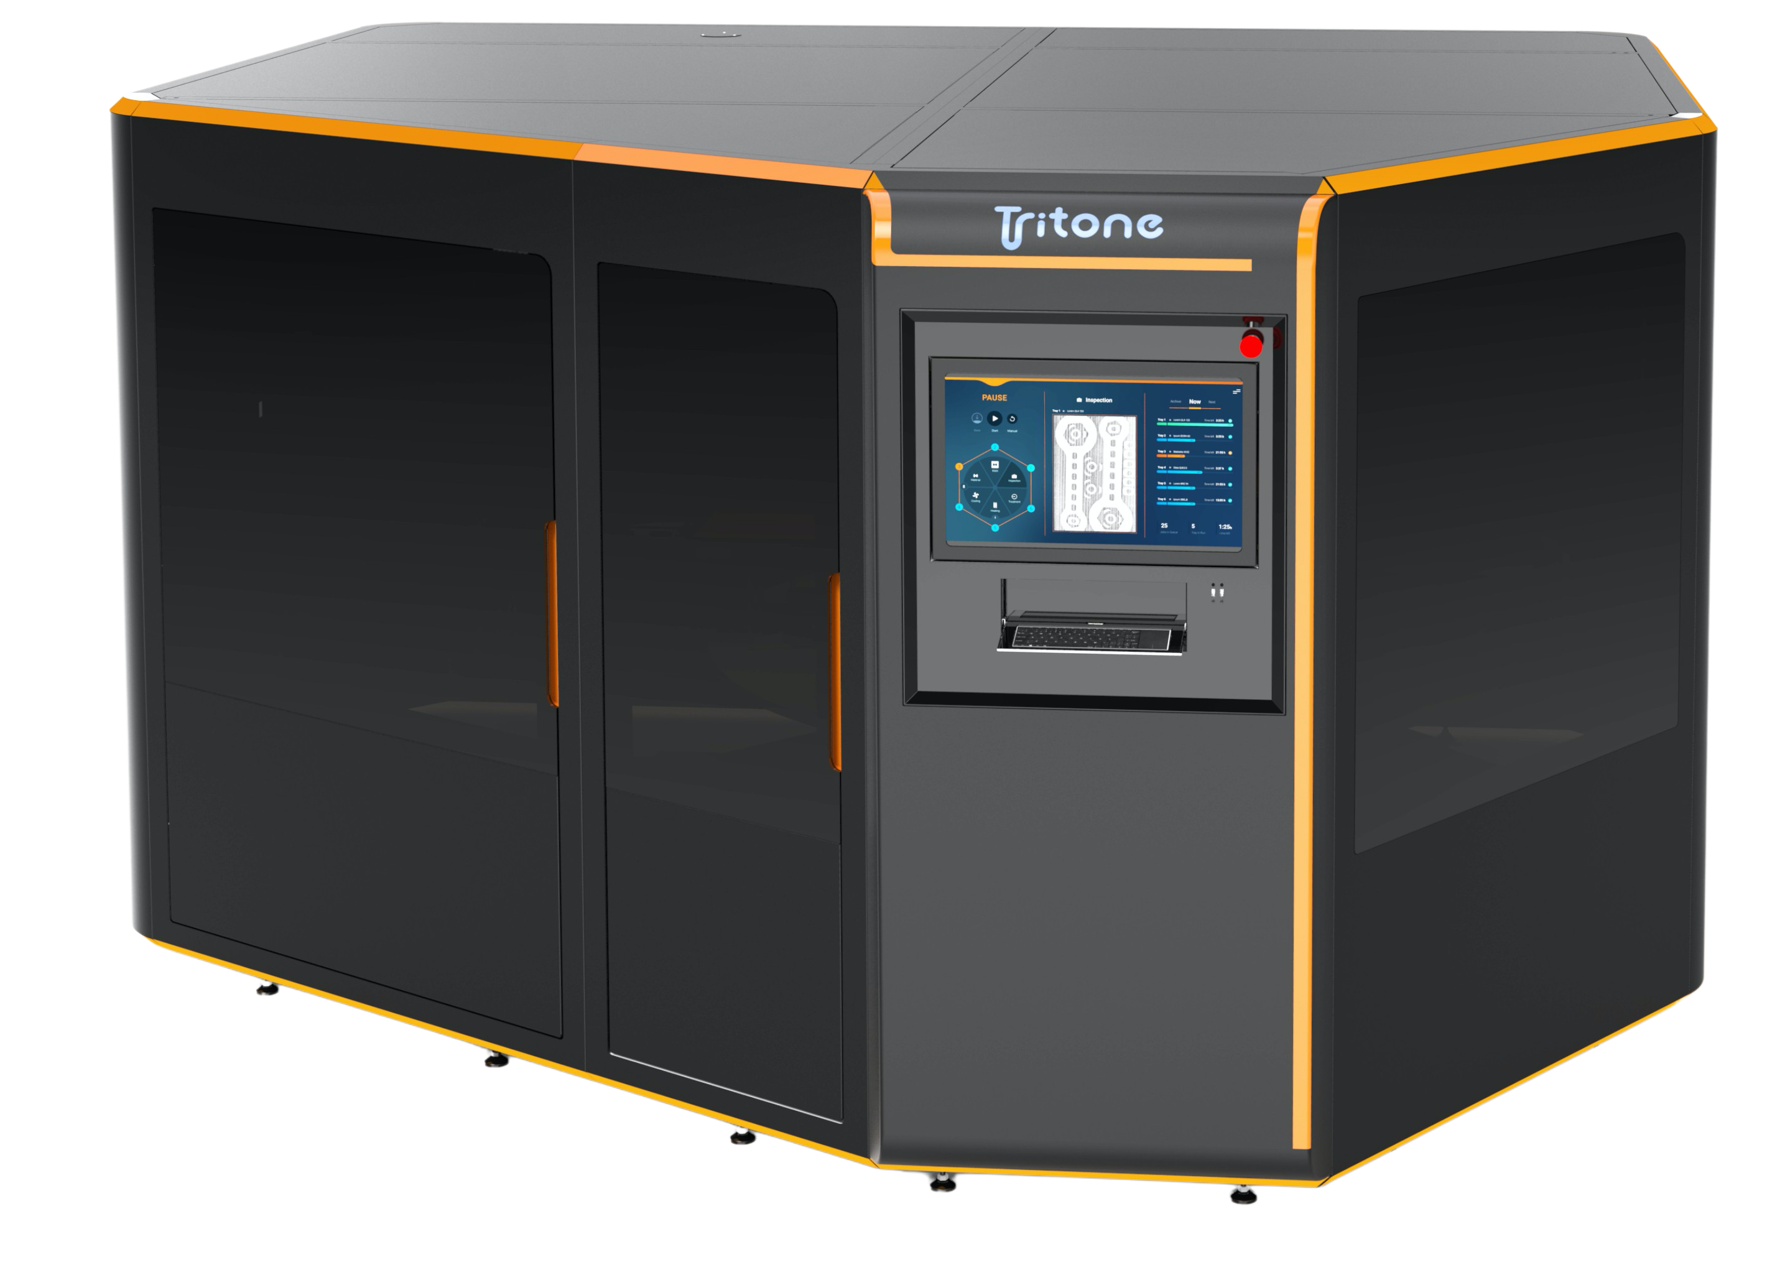 | 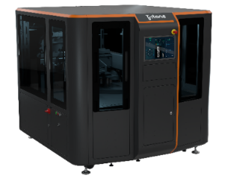
Below are the items to be included in a Tritone MoldJet Manufacturing Solution quotation.
For selling-prices refer to the pricelist.
- HARDWARE
NOTE: PART NUMBERS APPLY FOR EMEA & APAC ONLY

# | Item | Purpose & Description | Quantity | Price (€)
1 | Tritone (Dominant or Dim) AM System**  -90-DAMS-0001 for Dominant  -90-DAMS-0011 for Dim | Refer to the product page for details | 1
2 | Base Mold Unit  -91-BASE-0001 for Dominant  -91-BASE-1101 for Dim | Casts an initial mold-material layer (mold base) on the build-plate | 1
3 | Vibration Device  91-STAT-0002 | Build-material handling | 1
4 | Gyroscopic Mixer  51-MIXR-0006 | Build-material handling | 1
5 | Roll Ball Mill  51-RBAL-0007 | Build-material handling | 1
6 | Heated Cabinet  -51-INCU-0001 for Dominant  -51-INCU-1101 for Dim | Temperature-regulated storage chamber for completed build-plates | 1
7 | Demolding Oven (Memmert)  -33-DMLD-0002 for Dominant  -33-DMLD-0004 for Dim | Comes fully equipped with oven accessories (Pull-out Racks and drain-pan). | 1
8.1 | Solvent-demolding unit (LÖMI DA-30)  -51-LOMI-1401 water-cooled  -51-LOMI-2401 air-cooled | Includes installation. Prices do not include shipment. Comes fully equipped with a shelf-bracket frame for staging build-plates in the unit (PN 33-STND-0003). A larger, automated model can be offered when relevant (consult with Tritone HQ). | 1
9 | Glovebox  51-CHPR-0022 | Final cleaning of pre-sintered (‘green’) parts | 1

** Items included with the AM system:
Item | Quantity
Item | Dominant | Dim
Build-plate Assembly  -33-TABL-0003 for Dominant  -33-TABL-0005 for Dim | 8 | 5
Stainless Steel Tube-Cartridge  -33-TUBE-0011 2,500cc-cartridge (delivered with Dominant)  -33-TUBE-0010 300cc-cartridge (delivered with Dim) | 2
Cartridge Holder  33-HOLD-0041 | 1
Cartridge-plunger Extraction Jig  33-EXTR-0001 | 1 | 0
Installation kit (items and materials for installation & commissioning):  - Mold material: 6 kg (Dominant) / 4 kg (Dim)  - Build material – stainless steel: 16 kg (Dominant) / 6 kg (Dim)  - Additional tools, high-wear items and consumables supply for an estimated period of 3 months. | 1
- PRE-PRINT DESKTOP SOFTWARE
Software modules to be installed on a customer’s desktop computer (for system requirements see Tritone’s “Site Preparation Guide”):
# | Item | Purpose & Description | Quantity | Price (€)
1 | Core Package PYRAMIS  12-PRMS-0001 | Job preparation (positioning, scaling, etc.). This perpetual, hardware-key license is transferable between devices. | 1
2 | Tritone Studio 2.0*  20-TSSW-0001 | Final job preparation for print, enables MoldJet-specific features e.g. Dynamic Layer Thickness (DLT). | 1* | 0
*One license for “Tritone-Studio” module is included with the AM system.
- INSTALLATION & COMMISSIONING
# | Item | Purpose & Description | Quantity | Price (€)
1 | AM System Installation & Commissioning*  -00-INST-0001 for Dominant  -00-INST-1101 for Dim | Including training for operators. | 1
*Readiness of the installation-site, as defined in Tritone documents titled "Site Preparation Guide" (ref. 60-PREP-0001 and 60-PREP-1101), is a pre-requisite for installation and commissioning. Prices do not include shipment.
- Lead Time
# | Model | Approximate Lead Time*
1 | Tritone Dominant | PO + 4 months
2 | Tritone Dim | PO + 3 months
*Excluding shipment time.

- Total Price & additional Terms
- Quoted prices are under EXW terms and are exclusive of any taxes or bank transfer fees
- Payment terms: [complete this section according to reseller terms]
- This quotation is valid for 60 days after date of issue.

